|  |  |  |  |
| --- | --- | --- | --- |
| **Course Name:** | **EEEE** | **Semester:** | **II** |
| **Date of Performance:** | **03 / 04 / 2023** | **Batch No:** | **P1 - 2** |
| **Faculty Name:** |  | **Roll No:** | **16014022050** |
| **Faculty Sign & Date:** |  | **Grade/Marks:** | **/ 25** |

**Experiment No: 7**

**Title: Power factor improvement (series)**

|  |
| --- |
| **Aim and Objective of the Experiment:** |
| To improve power factor of a single-phase inductive AC circuit using capacitor in series with it. |

|  |
| --- |
| **Requirements:** |
| Inductor box, 1 KΩ-3W Resistor, Capacitor box, AC Ammeter and AC Voltmeter. |

|  |
| --- |
| **Theory:** |
| When we need to convert electrical energy to mechanical energy, electric motors are used for it. These AC motors converts electric energy in two forms namely mechanical energy in the form of rotary motion and other is magnetic field. Magnetizing currents are lagging to the supply voltage. This magnetic energy is not a mechanical energy so it is kind of wastage, but without which motor will not run and convert electric energy into mechanical energy. Such form of energy is called as reactive power. Reactive power must be as less as possible so that the load will utilize maximum power and current requirement will be less for the same amount power. As the current requirement is less, so wire thickness will be small in diameter. Installation cost and energy cost will be also reduced. To reduce reactive power of the circuit, different power factor improvement methods are used. One of the most familiar method is the use of capacitor bank. We can use capacitor in series with the load or across the load. Following diagrams are illustrating effect of PF on active power.  https://upload.wikimedia.org/wikipedia/commons/thumb/2/23/Power_factor_0.svg/300px-Power_factor_0.svg.png  In the above figure instantaneous and average power calculated from AC voltage and current with a zero-power factor {\displaystyle \cos \varphi =0}. The blue line shows all the power is stored temporarily in the load during the first quarter cycle and returned to the grid during the second quarter cycle, so no real power is consumed by the load which is shown by sky-blue colour line.  what is reactive power in electrical à¤¸à¤¾à¤ à¥ à¤à¤®à¥à¤ à¤ªà¤°à¤¿à¤£à¤¾à¤®  In the above figure instantaneous and average power calculated from AC voltage and current with a unity power factor{\displaystyle \cos \varphi =0}. The gray part shows all the power is absorbed in the load during the first half cycle as well as the second half cycle, so real power is fully consumed.  When power factor is between zero and unity, then real power consumed by the load depends upon PF of the circuit. Greater the power factor is always better to consume power.  BEEE_writeup |

|  |
| --- |
| **Circuit Diagram/ Block Diagram:** |
|  |

|  |
| --- |
| **Stepwise-Procedure:** |
| 1. Connect series R and L circuit across 230V, 1ø, 50 Hz AC supply and note down circuit voltage and current. 2. Calculate practical value of circuit power factor by taking ratio of active power (P) and apparent power (S). 3. Connect required value of capacitor in series with R-L load and switch on power supply to note circuit current. 4. Calculate practical value of circuit power factor by taking ratio of active power (P) and apparent power (S). 5. Compare theoretical and practical values of PF before connecting the capacitor and after connecting capacitor. |

|  |
| --- |
| **Observation Table:** |
| |  |  |  |  |  |  |  |  |  |  |  |  | | --- | --- | --- | --- | --- | --- | --- | --- | --- | --- | --- | --- | | **Sr no.** | **Type of load** | **Voltage (V)** | | **Current (mA)** | | **P (W)** | | **S (VA)** | | **Power factor** | | | **Th** | **Pr** | **Th** | **Pr** | **Th** | **Pr** | **Th** | **Pr** | **Th** | **Pr** | |  | **R-L** | **12.8** | 12.8 | 5 | 4.7 | 65 | 64.24 | 53.08 | 54.46 | 0.811 | - | | **R-L-C** | **12.8** | 13.0 | 5 | 5.4 | 65 | 70.74 | 53.08 | 57.77 | 0.811 | - | |

|  |
| --- |
| **Sample Calculations:** |
| Theoretical Calculations to find circuit current and PF of the inductive load:  Practical calculations to find PF of the inductive load:  Calculations to find value of the capacitor to be connected with the load: |

|  |
| --- |
| **Output Snapshots:** |
|  |

|  |
| --- |
| **Post Lab Subjective/Objective type Questions:** |
| 1. What are benefits of connecting capacitor across the load to improve circuit PF?     Capacitors provide a voltage boost, which cancels part of the drop caused by system loads. Switched capacitors can regulate voltage on a circuit. Capacitors work their magic by storing energy.  Capacitors are simple devices: two metal plates sandwiched around an insulating dielectric. When charged to a given voltage, opposing charges fill the plates on either side of the dielectric. The strong attraction of the charges across the very short distance separating them makes a tank of energy.  Capacitors provide power just when reactive loads need it. Just when a motor with low power factor needs power from the system, the capacitor is there to provide it. Then in the next half cycle, the motor releases its excess energy, and the capacitor is there to absorb it.  This benefits the system because that reactive power (and extra current) does not have to be transmitted from the generators all the way through many transformers and many miles of lines; the capacitors can provide the reactive power locally. This frees up the lines to carry real power, power that actually does work.   * Reactive component of network and the total current at the end tip system is reduced as well as the power loss, I square R in the system is reduced because the current decreases. The capacity of the electricity distribution network also increases, reduced the need to install additional capacity. * Low voltage drop * Saving in the power bill * Better usage of power system, lines and generators etc. (saving in energy as well as rating and the cost of the electrical devices and equipment is reduced) |

|  |
| --- |
| **Conclusion:** |
| In conclusion we can use a capacitor in series to improve the power factor of a single-phase inductive AC circuit. |

**Calculations done in lab:**

**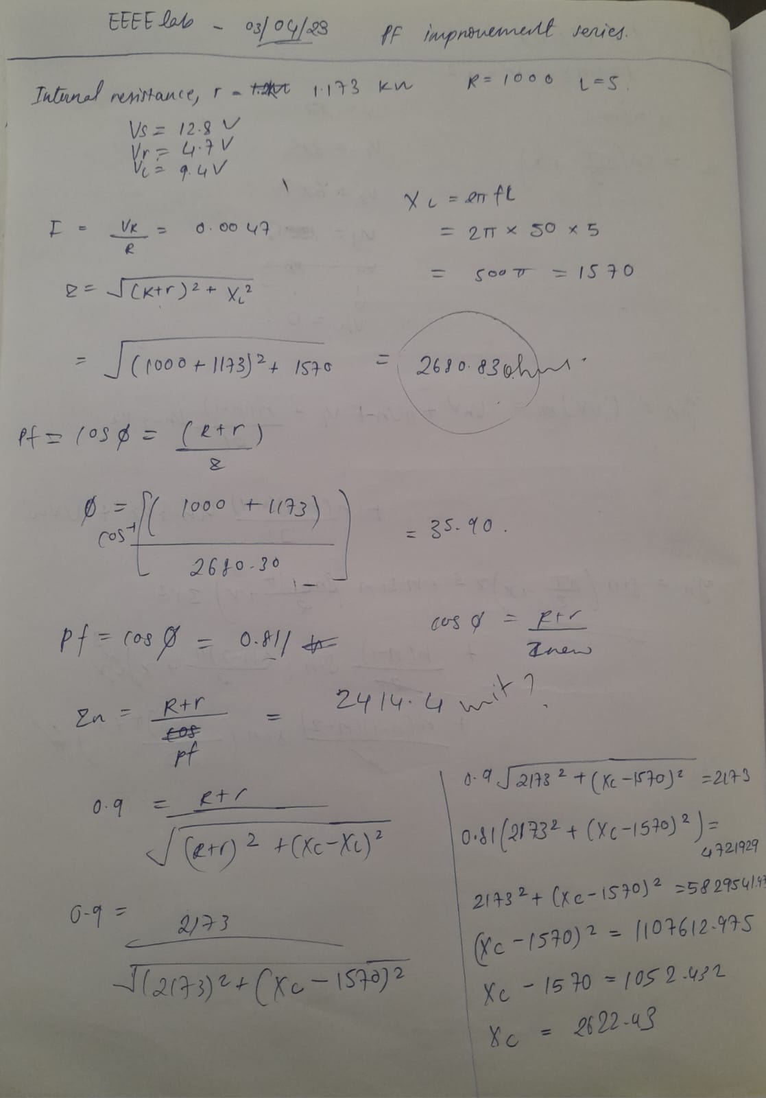**

****

|  |
| --- |
| **Signature of faculty in-charge with Date:** |